Workgroup C1.067

Planning and progress report student#4

20/02/2025

Aarón Jesús Acuña Bellido - [aaracubel@alum.us.es](mailto:aaracubel@alum.us.es)

Javier Arellano López – [javarelop@alum.us.es](mailto:javarelop@alum.us.es)

Raúl Calero Capote – [raucalcap@alum.us.es](mailto:raucalcap@alum.us.es)

Tudor Cristian Lacatus Cosma [-ionlac@alum.us.es](mailto:-ionlac@alum.us.es)

Miguel Prado Jiménez – [migprajim@alum.us.es](mailto:migprajim@alum.us.es)

Table of Contents

INTRODUCTION 4

PLANNING 4

Tasks performed 4

Screenshots 8

Budget 9

PROGRESS 10

Progress Report: 10

Conflicts 10

Cost Comparison 10

CONCLUSIONS 11

BIBLIOGRAPHY 11

Executive Summary:

This report includes the planning and progress of the tasks which correspond to the individual requirements of Student#4 during the first delivery.

Revision Table

|  |  |  |
| --- | --- | --- |
| Revision Number | Date | Description |
| 1.0 | 20/02/2025 | Initial version of the planning and progress report |
|  |  |  |
|  |  |  |

# INTRODUCTION

This report provides a description of the planning I made and followed during the development of the first deliverable and also the progress I made in it. It has a list of the tasks with relevant details, some screenshots to illustrate the progress and finally and estimation cost and a comparison with the real one.

# PLANNING

## Tasks performed

The tasks contained in the original plan are the following:

**Title:** Task 012-Modify the anonymous menu (Student#4)

**Description:**

Modify the anonymous menu to show an option that takes the browser to the home page of your favourite website. The title must read as follows:

* “〈id-number〉: 〈surname〉, 〈name〉”, where “〈id-number〉” denotes your DNI, NIE, or passport number, “〈surname〉” denotes your surname/s, and “〈name〉” denotes your name/s.
* Make sure that you modify both the English and Spanish version.

**Assignee/s**: Miguel Prado Jiménez (mpradoj04 in GitHub)

**Role/s:** Developer

**Expected Time:** 10 minutes

**Time Spent:** 10 minutes

**Title:** Task 030-Provide a link to Student’s#4 dashboard

**Description:** Provide a link to Student’s#4 planning dashboard in GitHub to review the tasks, their current status, and your schedule. This link must be contained in a document contained in the folder: reports/Deliverable1/Student#4

**Assignee/s**: Miguel Prado Jiménez (mpradoj04 in GitHub)

**Role/s:** Operator

**Expected Time:** 5 minutes

**Time Spent:** 5 minutes

**Title:** Task 031- Create analysis report (Student#4)

**Description**: Given the tasks assigned to Student#4, make an analysis report of them following the guideline provided in the Annexes. Place it in the corresponding folder to that student.

**Assignee/s**: Miguel Prado Jiménez (mpradoj04 in GitHub)

**Role/s:** Analyst

**Expected Time:** 1 hour

**Time Spent:** 1 h and 20 min

**Title:** Task 032- Create a P&P report (Student#4)

**Description:** Given the tasks assigned to Student#4, make a planning and progress report of them following the guideline provided in the Annexes. Place it in the corresponding folder to that student.

**Assignee/s**: Miguel Prado Jiménez (mpradoj04 in GitHub)

**Role/s:** Analyst

**Expected Time:** 2 hours and 45 min

**Time Spent:** 2 hours and 40 min

In addition, I will also remark the group task assigned to me as Student#4.

**Title:** Task 006- Produce a report on the set up of the development configuration (Group)

**Description:** Produce a report about the set up of the development configuration. It must at least complete the following sections:

* Cover: It must display group number, repository, names of team members, e-mail addresses and date
* Table of contents
* Executive summary
* Revision table
* Introduction
* Content: You must not reproduce the guideline to set it up, but just make clear that we have all followed it and we have the development configuration ready to work.
* Conclusions
* Bibliography (if any). Else, write "Intentionally blank"

**Assignee/s**: Miguel Prado Jiménez (mpradoj04 in GitHub)

**Role/s:** Analyst

**Expected Time:** 1 hour

**Time Spent:** 1 hour and 15 min

**Title:** Task 006/R1 - Review the report on the development configuration(Group)

**Description**: Justify content and eliminate blank spaces in the report of task 006.

**Assignee/s**: Miguel Prado Jiménez (mpradoj04 in GitHub)

**Role/s:** Analyst

**Expected Time:** 5 min

**Time Spent:** 5 min

**Title:** Task 018- Configure the working environment (Group)

**Description**: Prepare all the necessary conditions for the instantiation of the project.

**Assignee/s**: Miguel Prado Jiménez (mpradoj04 in GitHub)

**Role/s:** Developer

**Expected Time:** 2 h

**Time Spent:** 2 h and 30 min

Now, here I describe the tasks for testing the individual tasks of Student#4:

**Title:** Task 030/T1 - Test the link to Student#4's dashboard

**Description**: Check that the link provided to the dashboard of Student#4 correctly reflects all of the related tasks for his individual requirements.

**Assignee/s**: Aarón Jesús Acuña Bellido (aaronacuuna in GitHub)

**Role/s:** Tester

**Expected Time:** 5 min

**Time Spent:** 5 min

**Title:** Task 012/T1 - Test Student#4 favourite link

**Description**:

* Check that it is properly rendered
* Check that it is available in both the english and Spanish menu
* Check that it is only under Anónimo/Anonymus
* Check that it follows the naming structure of the individual requirements

**Assignee/s**: Tudor Cristian Lacatus Cosma (tcosma in GitHub)

**Role/s:** Tester

**Expected Time:** 5 min

**Time Spent:** 5 min

**Title:** Task 031/T1- Create analysis report (Student#4)

**Description**: • Check that it falls under the right folder  
• Check that it meets the structure of the Annexes  
• Look for orthographical and grammatical mistakes  
• Check that the links to the EV forum work correctly  
• Check that the requirements are correctly analyzed

**Assignee/s**: Aarón Jesús Acuña Bellido (aaronacuuna in GitHub)

**Role/s:** Tester

**Expected Time:** 10 min

**Time Spent:** 10 min

**Title:** Task 032/T1- Create a P&P report (Student#4)

**Description**: • Check that it falls under the right folder  
• Check that it meets the structure of the Annexes  
• Look for orthographical and grammatical mistakes

**Assignee/s**: Raúl Calero Capote

**Role/s:** Tester

**Expected Time:** 30 min (RauruWG in GitHub)

**Time Spent:** Not available at the moment

## Screenshots

Here are attached screenshots taken during the process of the project, showing different stages of the development.

**Tasks in the middle of the process:**

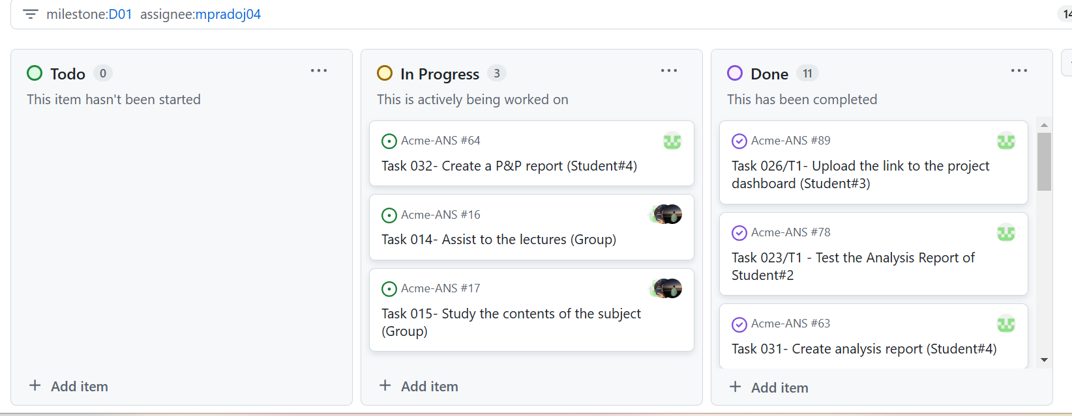

**Tasks in the done lane:**

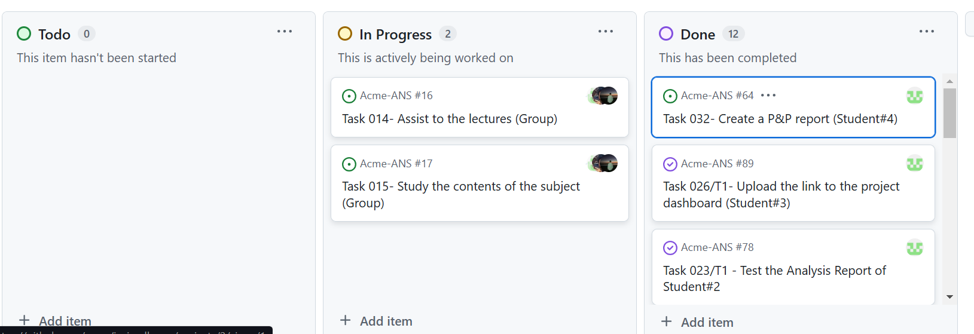

The tasks in the progress lane are assiting to the lectures and studying, something that will be done the whole semester

## Budget

The budget for this delivery is calculated taking into account the time spent in the project as mentioned above. For the remuneration, each role has a different amount. The assignation of the roles have been assumed depending on the task nature. The remuneration is the following:

* Project Managers and analysts: €30.00 per hour
* Developers, testers, and other roles: €20.00 per hour

The total budget is:

|  |  |  |  |
| --- | --- | --- | --- |
| Role | Hourly Rate (€) | Estimated time(hrs) | Estimated cost (€) |
| Project Manager | 30 | 0 | 0 |
| Analyst | 30 | 4,83 | 144,9 |
| Developer | 20 | 2,16 | 43,2 |
| Tester | 20 | 0,9 | 18 |
| Operator | 20 | 0.08 | 1.60 |
| Totals: |  | 7,97 | 207,7 |

For this project to be carried out it is also necessary to use a laptop or personal computer, whose estimated cost is 1,150€, and which is amortized in 36 months (having each month 4 weeks). As follows, the weekly amortization is

Amortization cost per week = 1150/(36*4) = 7,99 €

Now, taking into account the length of the first deliverable, 3 weeks, we add the amortization to the final amount.

Thus, the cost is of 231,67

# PROGRESS

## Progress Report:

In the following record, a performance indicator is used to measure my performance in the individual tasks

**Feedback session 1 (18/02/2025):**

As the lecturer strongly advised us to, the “Actual Grade vs Expected Grade” performance indicator is used. Up to this date I had not being able to start my individual tasks, but I was expected to have my favourite link in the anonymous menu.

Result= 0 – 1 = -1. Meaning I was doing something wrong, I had to catch up to work or in other case my work and my colleages would be affected.

## Conflicts

No conflicts have occurred during this time period

## Cost Comparison

In this section a comparison between the expected amount of time, and thus cost, and the actual costs will be made.

Following the same procedure as before with the actual cost, now the expected will be computed. We will assume that the tasks not yet completely took the time expected to.

|  |  |  |  |
| --- | --- | --- | --- |
| Role | Hourly Rate (€) | Time spent(hrs) | Real cost (€) |
| Project Manager | 30 | 0 | 0 |
| Analyst | 30 | 5,3 | 159 |
| Developer | 20 | 2,66 | 53,2 |
| Tester | 20 | 0,9 | 18 |
| Operator | 20 | 0.08 | 1.60 |
| Totals: |  | 8.94 | 231.8 |

Adding the amortization costs, the final cost of the deliverable would be of 255,77

Comparing both it is clear that the real cost has been greater than the estimated one. We would have lost 24.1€. This indicates a incorrect estimation effort

# CONCLUSIONS

In this document, I have described my planning and progress in the first delivery. Thanks to my own effort, and to the help of my colleages I have managed to complete every task I was assigned.

On the other hand, even though I completed all, my estimation was not correct. This would have resulted in a professional project in money loss.

This is clearly because I did not spend the time necessary at the beginning. A better time schedule must be prepared for the following deliverables

# BIBLIOGRAPHY

Intentionally blank